**MCA Spring Conference 2025**

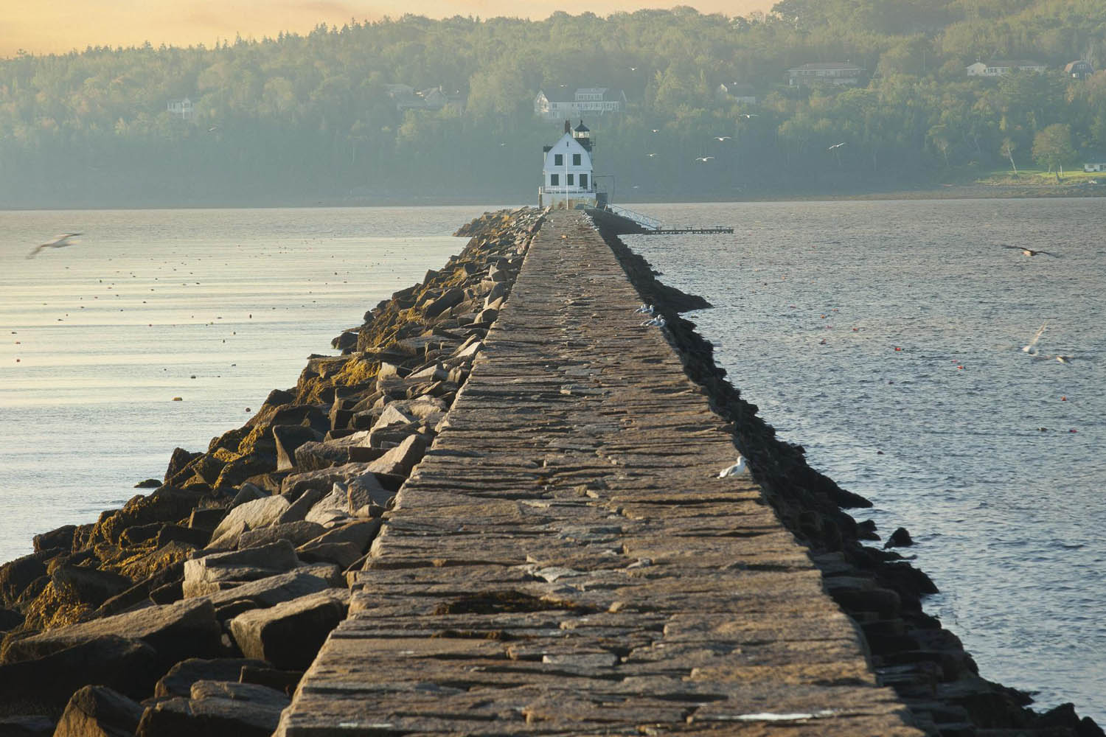

**Committed to Chiropractic Excellence**

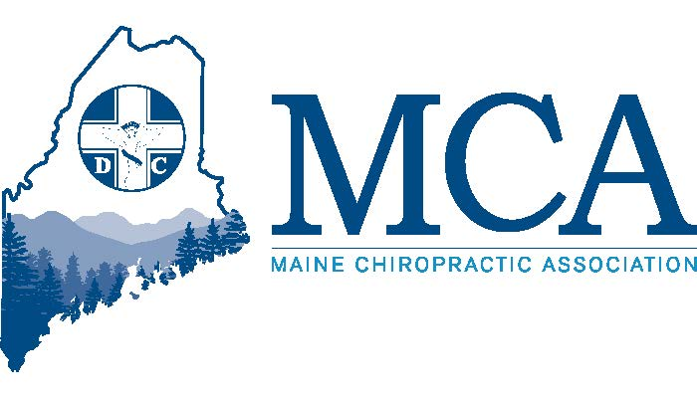

**April 25th – 27th 2025 Samoset Resort, Rockport Maine**

**Contact the Samoset at (207) 594-2511 for rooms starting at $169 per night.**

**Or Go Online for Reservations -**  **https://shorturl.at/IMKCq**

**Schedule**

**FRIDAY**

**6:00 PM – 7:30 PM**

**Your dinner is provided with compliments of the MCA Chiropractic Action Fund and MedCorPro. You will enjoy amazing food and then enter a lively hands-on training module learning about the benefits of Shockwave by the talented team at MedCorPro. Learn when and how to get the best results for your patients.**

**An exhibitor’s welcome reception will follow for all attendees.**

**SATURDAY/SUNDAY SPEAKERS**

**This spring we focus on the athlete – with talks on various injuries to everyone from the weekend warrior to that trained athlete. We will cover identifying the cause, treating the issue, and conditioning to avoid these injuries. Our speakers will include**

**Dr. Kurt Juergens – Dr. Juergens will cover common injuries for the weekend athlete – whether it is biking, running, golf, pickleball or something else – learn how to recognize and treat common injuries in the casual athlete. Sponsored by Foot Levelers**

**Dr. John Hayes – Dr. Hayes will offer a program covering golfing injuries – evaluation & treatment. Dr. Hayes was a member of the Performance and recovery team treating Senior PGA players at the USGA Senior Open in Newport Rhode Island recently and provides amazing insight into golfers and their common injuries.**

**Dr. James Lehman – Dr Lehman is the Director of Postgraduate Studies at the University of Bridgeport and will offer a program on the treatment of whiplash patients and a second two-hour program covering statin myopathy.**

**Dr. Brendan McCann – Dr. McCann will speak on Ehler Dahlos syndrome, a group of inherited disorders that affect your connective tissue – primarily your skin, joints, and blood vessel walls. Common signs/symptoms include overly flexible joints, stretchy skin, and fragile skin.**

**Laser Lab - Join Drew Grennell of Cutting Edge Laser technology as he shares an overview of different lasers used in patient care, shares case studies regarding the weekend warrior and guides you through incorporating laser therapy into your practice.**

**New for 2025**

**In addition to our two tracks for DC’s we have added a few new items for 2025 based on your feedback.**

**Friday – Weather permitting, we will offer an informal golf tournament after lunch for our members and exhibitors. If the greens are open, you will be able to have friendly competitions with friends and compete for bragging rights. Closest to the pin? Low score? Team play? Drive for show, putt for dough!**

**Saturday – All day – Your staff is invited to join our therapy suite presentation where we will spend time with hands-on demonstrations of Shockwave, Laser, Electric Stimulation, Ultrasound, Decompression and more. For anyone with a Temporary Chiropractic Assistant or Certified Chiropractic Assistant license in Maine we offer a $25 discount to attend AND we will welcome them to have lunch with us on Saturday as well as any break refreshments while visiting out Exhibitor Hall .**

**Sunday – Onsite CPR training. We will offer 2-hour class at 8 AM & at 10:30 AM Sunday morning for those wishing to be certified on CPR. Class provided by Maine Mobile CPR and limited to eight to ten participants per class. The cost will be $75.00 per person separate from conference registration and is offered for doctors and staff. This will be a separate registration so please email or call if you would like to register for this class.**

**Saturday Banquet – Join us as we celebrate our annual awards recipients and our next Champions of Chiropractic Honorees. Appetizers and cocktails first in our Exhibitor Hall from 530 PM – 6:30 PM, followed by the sit down served banquet upstairs at 6:30 PM. Cost is $100.00 per person, $40.00 for children twelve and under and spouses, family and staff are welcome to register.**

**MCA EVENT REGISTRATION**

**Early Bird Discount (Ends 4/11/25) Late Registration**

**MCA Member Doctor $349.00 _____ MCA Member Doctor $399.00 _____**

**Non-Member Doctor $499.00 _____ Non-Member Doctor $549.00 _____**

**Chiropractic Students* $ 75.00 _____ Chiropractic Students $ 100.00 _____**

**Chiropractic Staff $ 75.00 _____ Chiropractic Staff $ 100.00 _____**

**Temp & Certified CA Staff $ 50.00 _____ Chiropractic Staff $ 75.00 _____**

**Saturday Banquet Tickets adult #_____ $ 100.00 _____ children # ______ $ 40.00**

**\*Student Scholarships available upon request from the MCA for this event**

**___ Check here if you will be attending the Friday evening CE program. Dinner on Friday is included at no charge for doctors and additional dinner tickets for spouses and/or staff can be purchased for $40.00.**

**Attendee Name(s):  *__________________________________________________________________***

**Address: ___________________________________________ City _________________ ZIP _________**

**Email:_______________________________________________________________________________**

**Register online at** [**www.mainechiro.com**](http://www.mainechiro.com)**, by fax (207) 782-5482 or by mail to: MCA, 58 Albert Street Lewiston ME 04240**

**Payment Options:**

**Please charge $ _________ to my ____VISA ____Mastercard _____AM EX or Check # _________________(enclosed)**

**Cardholder Name: _________________________________Signature : _______________________________________**

**Credit Card # ______________________________________ Expiration Date: _____________ Zip Code: ___________**

February 13, 2025

Dear Doctor,

The MCA is excited to return to the Samoset Resort for another welcome to spring event. This is a fantastic opportunity to bring staff for an education and fun weekend!

Our Education Committee is committed to providing quality speakers, important topics and to empowering our members’ voices with opportunities to present their findings and we are excited to be working with LifeLynx to sponsor our member talent.

New this spring will be an informal golf tournament on Friday afternoon (weather and course conditions dependent), Saturday will include a therapy demonstration suite where your staff can be hands on with the latest equipment for chiropractic offices. Trained instructors will showcase when and how to use the equipment, what conditions it treats and more on Saturday. Saturday evening marks our second installation of the Champions of Chiropractic gala celebration as we induct up to five more members. Lastly, Sunday morning offers an additional opportunity for CPR training.

By the time of spring conference, we hope to formally announce our Fall Conference speakers and are finalizing those details currently. We can promise a conference that you will not want to miss attending. Mark your calendars for October 17th- 19th at the Sheraton Sable Oaks in South Portland.

The Maine Chiropractic Licensing Board currently requires 36 hours of in-person Continuing Education learning plus 12 hours of other learning each biennium and 2025 marks the second year of the biennium. All 48 hours must be complete by 12/31/2025 and prior to renewing your license.

We look forward to seeing everyone there in person. We apologize for having to raise the fees slightly, but costs at the facility have increased significantly since COVID and we do everything possible to limit costs to our doctors.

See you at the Samoset!

Robert Reed,

Executive Director, MCA